Setting up Book Group Security

- Open Sendero.
- Go to Admin -> User -> Roles
- Go to the row marked with an asterisk (*).
- In the Role Code column enter a new role code for D0234.
- Press the enter key.
- Close the form and then reopen it.
- Make sure the radio button Functions For Roles is selected.
- Expand the functions for this role by clicking the + sign next to D0234.
- Only certain functions are book group sensitive, the functions are:
  - AdminBooks
  - PositionBoxSummary
  - PositionContractBlotter
  - PositionDealBlotter
  - PositionOpenContracts
  - PositionRecalls
- Each function that can be assigned a book group will have a [NONE] in the Book Group List Column.
- There are three possible values for these functions:
  - [ALL] – Which will allow the user assigned this role to view/edit all book group information.
  - [NONE] – Which will not allow the user assigned this role to view/edit any book group information.
  - 0234;7380; - Which will allow a user assigned this role to view/edit the book group information for the book groups specified in the list.
- For setting up this role, we only want to give the user access to 0234. So for each function we will insert 0234; for the book group. When you finish it should look like the picture below.
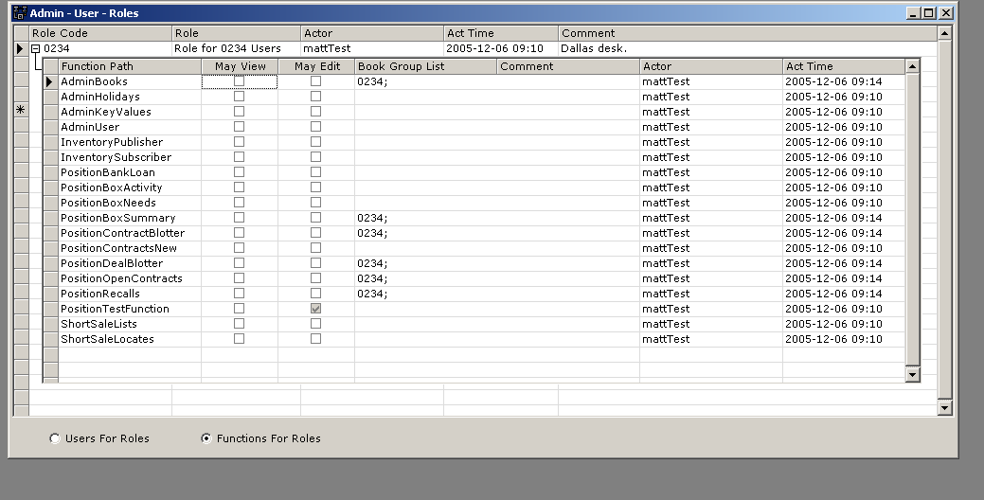
- Repeat the same process above for book group 7380, substituting 7380 for 0234.
- Go to Admin->User->Personnel.
- For every user expand the child grid by clicking the + next to the User ID, select the row if a role exists and press delete.
- Next inside the Role Code column and a drop down menu will appear. Select the role you want to assign to this user.
- Press enter.
- Then simply move off the row to accept the changes.
- Repeat the process for every user. No user should have the ADMIN role.
- If a user requires access to both book groups then simply assign them both roles.

